CLB6 Mortgage Research

How much can I afford?

- Go to https://www.realtor.ca/
  - Search by map for a property in an area that you would like to live

- Listing Price: _________________________

Maintenance Fees/Condo Fees: _________________ per month

- Click on Financial
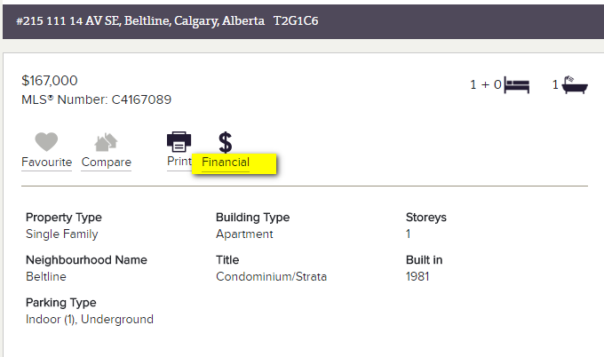

- Now, open another window in your internet browser and find some current mortgage rates
  - Go to your personal bank’s website, or check out TD bank mortgage rates https://www.tdcanadatrust.com/products-services/banking/mortgages/mortgage-rates.jsp
  - What is the 3 year closed fixed rate? _________________________
  - What is the 5 year closed fixed rate? _________________________
  - What is the 5 year open variable rate? _________________________

- Now return to your realtor.ca listing and fill in the following information under “financial”
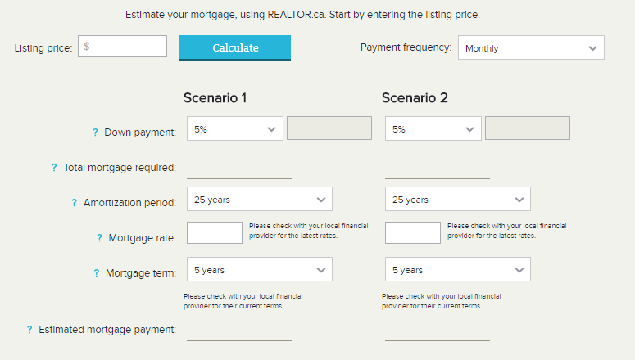

INSTRUCTIONS | FILL IN NUMBERS HERE
Listing Price | $
Down Payment: Choose between 5-20% | ____________ % $__________________
Total Mortgage Required: the computer will calculate the amount you need to borrow | $
Amortization Period: Choose 25 years | 25 years
Mortgage rate: Choose a mortgage rate from your bank’s website | ____________ %
Mortgage Term: Choose 5 years | 5 years
Estimated mortgage payment: | $
Mortgage payment + maintenance/condo fees | $

- Now try this again with another property or with changing the numbers of your mortgage rate or down payment.
INSTRUCTIONS | FILL IN NUMBERS HERE
Listing Price | $
Down Payment: Choose between 5-20% | ____________ % $__________________
Total Mortgage Required: the computer will calculate the amount you need to borrow | $
Amortization Period: Choose 25 years
Mortgage rate: Choose a mortgage rate from your bank’s website | ____________ %
Mortgage Term: Choose 5 years
Estimated mortgage payment: | $
Mortgage payment + maintenance/condo fees | $

